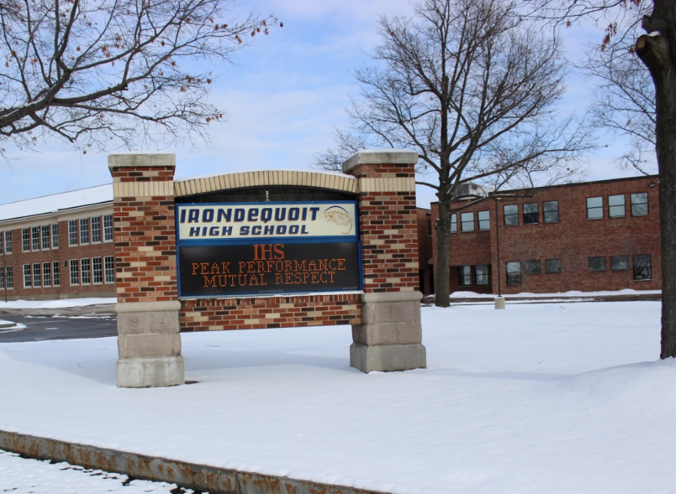

MINIMUM CAPACITY :-

The Minumum intake capacity

of students is between 300-620

children

LIBRARY :-

The Libarary is Available.

CANTEEN:-

The Canteen Facility is Available.

BOARDING :-

No availablility of boarding.

SPORTS :-

There are different categories

sports available.

Girls Volleyball

Boys Volleyball

Football

|  |  |  |
| --- | --- | --- |
| IRONDEQUOIT HIGH SCHOOL  ROCHESTER - SCHOOL |  |  |
|  |  |  |
| School Detail :- Irondequoit High School is a public high school in the town of Irondequoit, a major suburb of Rochester, New York  Irondequoit High School is a highly rated, public school located in ROCHESTER, NY. It has 1,149 students in grades 9-12 with a student-teacher ratio of 12 to 1. According to state test scores, 98% of students are at least proficient in math and 97% in reading.  Many families consider multiple schools of various types: public, private, charter, magnet. The Niche K12 Compare Tool can help you narrow your options and easily add them to your list of schools with the heart icon. If you want to get even more information about a school and read reviews from students and parents, the full Niche Profile for the school is just a click away. |  |
|